
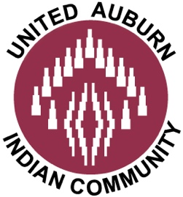
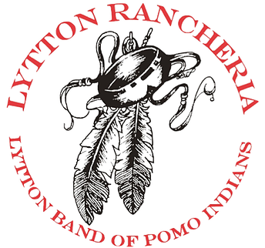
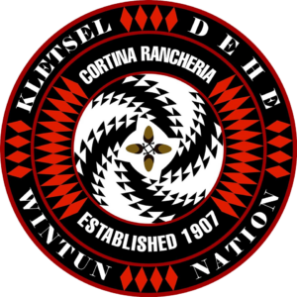

Joint Tribal Statement on Scotts Valley Band Plans to Open “Preview Casino” in Vallejo, CA
Tribes Cite Ongoing Federal Review and Judicial Warnings
FOR IMMEDIATE RELEASE CONTACT: Doug Elmets
January 30, 2026 916-329-9180
NORTHERN CALIFORNIA — The Yocha Dehe Wintun Nation, the Kletsel Dehe Wintun Nation, the Lytton Rancheria of California, and the United Auburn Indian Community today expressed serious concern as the Scotts Valley Band of Pomo Indians moves toward opening a temporary “preview casino” in Vallejo, while the U.S. Department of the Interior continues an active reconsideration of the project’s gaming eligibility.
Any move to proceed at this time would come despite a clear warning from the federal court overseeing the matter that Scotts Valley would be “ill-served” by relying on the temporary restoration of gaming eligibility while the Department completes its reconsideration, which the Court has directed be conducted expeditiously and thoroughly.
“The court was explicit that its ruling should not be viewed as a green light to proceed with gaming activity while the federal review is ongoing,” said Anthony Roberts, Chairman of the Yocha Dehe Wintun Nation. “Moving forward with this short-term cash grab ignores the Court’s warning, disrespects the reconsideration process, and jeopardizes the City of Vallejo’s limited public safety and other resources for its citizens.”
The tribes emphasized that the issue is not competition, but respect for the rule of law, tribal sovereignty, and the integrity of the federal review process, particularly where significant questions remain about gaming eligibility, historical connection to the land, and potential environmental and cultural impacts.
“Our concern here is specific and process-based,” said Chairman Wright of the Kletsel Dehe Wintun Nation. “Where the Department of the Interior is actively reconsidering gaming eligibility, and the court has cautioned against reliance on interim decisions, moving forward with gaming activity at this site before that review is complete risks undermining trust in the process and creating avoidable conflict among tribes and local communities.”
“This is not about opposing economic development,” said Chairperson Andy Mejia of the Lytton Rancheria of California. “It is about ensuring that development occurs lawfully, responsibly, and in a manner that honors tribal history and federal law. Proceeding with a casino, even a so-called ‘preview’ facility, while the Department of the Interior is actively reconsidering its own decision risks undermining the integrity of the federal review process.”
The tribes noted that the Department of the Interior has explicitly acknowledged that its earlier approval may have been based on legal error. They further noted that substantial evidence submitted by local tribes was not considered, raising serious questions about whether the Vallejo site qualifies for gaming under the Indian Gaming Regulatory Act.
“Rushing forward in the face of unresolved legal questions does not create certainty or shared prosperity,” said Chairman John Williams of the United Auburn Indian Community. “It puts Vallejo, the Tribe, and neighboring communities in an untenable position if the Department ultimately determines that the land is not eligible for gaming.”
The tribes reiterated their call for the Scotts Valley Band to pause any gaming operations until the federal reconsideration is complete and a final, lawful determination is issued.
“We respect the sovereignty of all Tribes,” the joint statement concluded. “That respect includes honoring the courts, the federal process, and the rights of neighboring tribes whose ancestral, cultural, and historical ties to this land are at stake.”
###

